Endnotes Instructions and Cheat Sheet

- When using Chicago Manual of Style, 16th Edition format in endnotes (also called “notes”), titles of books, articles, and journal names are capitalized headline style.

- Author first names are spelled out in full, and precede the author’s last name.

- If you are using EndNote, Zotero, or a similar reference software program, note that the software often uses the incorrect version of the Chicago Manual of Style’s endnotes—it often defaults to the author-date endnotes system, where the last name precedes the first. Please ensure that you are using the “notes” style of Chicago’s endnotes, with the rules of the first two bullets intact. You may need to visit your reference software’s downloads page to incorporate the correct style of endnotes.

- Note that bibliographies have a slightly different style; see CMS chapter 14, especially 14.16, 14.18, 14.56–14.67.

- Examples of notes below are followed by shortened versions of citations to the same source to be used on subsequent, nonsequential references in the same endnote list for a chapter. If the subsequent reference directly follows the original reference, please use “Ibid.” and include the appropriate page numbers. For instance:

Michael Pollan, The Omnivore’s Dilemma: A Natural History of Four Meals (New York: Penguin, 2006), 99–100.
Ibid., 3.

- Note that endnote numbers are to be placed at the end of a sentence, rather than in the middle. If multiple citations are needed for a sentence, only one endnote is needed. Multiple citations can be linked with a semi-colon.

- You must embed endnotes in your chapters using the “Insert Endnote” feature in Microsoft Word (located in the “References” tab—see below):

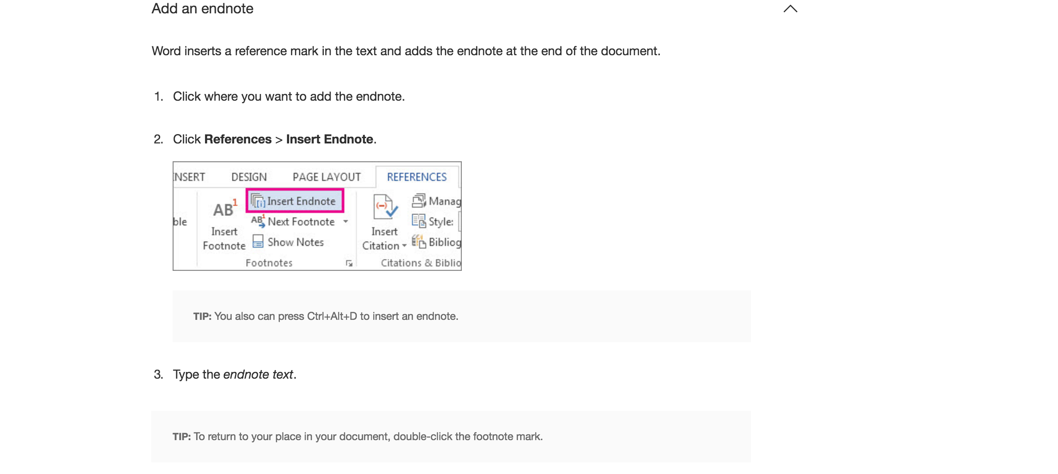

Books

One author

1. Michael Pollan, The Omnivore’s Dilemma: A Natural History of Four Meals (New York: Penguin, 2006), 99–100.

…

3. Pollan, Omnivore’s Dilemma, 3.

Two or more authors

1. Geoffrey C. Ward and Ken Burns, The War: An Intimate History, 1941–1945 (New York: Knopf, 2007), 52.

…
3. Ward and Burns, War, 59–61.

Four or more authors

For four or more authors in an endnote, list only the first author, followed by et al. (“and others”):

1. Dana Barnes et al., Plastics: Essays on American Corporate Ascendance in the 1960s . . .

…

3. Barnes et al., Plastics . . .

Editor, translator, or compiler instead of author

1. Richmond Lattimore, trans., The Iliad of Homer (Chicago: University of Chicago Press, 1951), 91–92.

…

3. Lattimore, Iliad, 24.

Editor, translator, or compiler in addition to author

1. Gabriel García Márquez, Love in the Time of Cholera, trans. Edith Grossman (London: Cape, 1988), 242–55.

…

3. García Márquez, Cholera, 33.

Chapter or other part of a book

1. John D. Kelly, “Seeing Red: Mao Fetishism, Pax Americana, and the Moral Economy of War,” in Anthropology and Global Counterinsurgency, ed. John D. Kelly et al. (Chicago: University of Chicago Press, 2010), 77.

…

3. Kelly, “Seeing Red,” 81–82.

Several chapters from same contributed volume

4. William H. Keating, “Fort Dearborn and Chicago,” in Prairie State: Impressions of Illinois, 1673–1967, by Travelers and Other Observers, ed. Paul M. Angle (Chicago: University of Chicago Press, 1967), 84–87.
27. Sara Clarke Lippincott, “Chicago,” in Angle, Prairie State, 362–70.

Preface, foreword, introduction, or similar part of a book

1. James Rieger, introduction to Frankenstein; or, The Modern Prometheus, by Mary Wollstonecraft Shelley (Chicago: University of Chicago Press, 1982), xx–xxi.

…

3. Rieger, introduction, xxxiii.

Book published electronically
If a book is available in more than one format, cite the version you consulted. For books consulted online, list a URL. If no fixed page numbers are available, you can include a section title or a chapter or other number.
1. Jane Austen, Pride and Prejudice (New York: Penguin Classics, 2007), Kindle edition.
2. Philip B. Kurland and Ralph Lerner, eds., The Founders’ Constitution (Chicago: University of Chicago Press, 1987), http://press-pubs.uchicago.edu/founders/.
3. Austen, Pride and Prejudice.
4. Kurland and Lerner, Founder’s Constitution, chap. 10, doc. 19.

Reports, pamphlets, and the like

Pamphlets, corporate reports, brochures, and other freestanding publications are treated essentially as books.

35. Lifestyles in Retirement, Library Series (New York: TIAA-CREF, 1996).

Journal articles

Article in a print journal
In a note, list the specific page numbers consulted, if any.
1. Joshua I. Weinstein, “The Market in Plato’s Republic,” Classical Philology 104 (2009): 440.

…

3. Weinstein, “Plato’s Republic,” 452–53.

Article in an online journal
Include a DOI (Digital Object Identifier) if the journal lists one. A DOI is a permanent ID that, when appended to http://dx.doi.org/ in the address bar of an Internet browser, will lead to the source. If no DOI is available, list a URL. Access dates are not required.
1. Gueorgi Kossinets and Duncan J. Watts, “Origins of Homophily in an Evolving Social Network,” American Journal of Sociology 115 (2009): 411, doi:10.1086/599247.

…

3. Kossinets and Watts, “Origins of Homophily,” 439.

Journal with volume, issue, and date

2. David Meban, “Temple Building, Primus Language, and the Proem to Virgil’s Third Georgic,” Classical Philology 103, no. 2 (2008): 153, doi:10.1086/591611.

23. Boyan Jovanovic and Peter L. Rousseau, “Specific Capital and Technological Variety,” Journal of Human Capital 2 (Summer 2008): 135, doi:10.1086/590066.

Journal with no volume number or date only

1. Beattie, J. M. “The Pattern of Crime in England, 1660–1800.” Past and Present, no. 62 (1974): 47–95.
2. Saberhagen, Kelvin. “Lake Superior Beluga?” Sturgeon Review, Winter 1928, 21–45.

Articles in a newspaper or popular magazine
Newspaper and magazine articles may be cited in running text (“As Sheryl Stolberg and Robert Pear noted in a New York Times article on February 27, 2010, . . .”) instead of in a note, and they are commonly omitted from a bibliography. The following examples show the more formal versions of the citations. If you consulted the article online, include a URL; if no author is identified, begin the citation with the article title.
1. Daniel Mendelsohn, “But Enough about Me,” New Yorker, January 25, 2010, 68.
2. Sheryl Gay Stolberg and Robert Pear, “Wary Centrists Posing Challenge in Health Care Vote,” New York Times, February 27, 2010, http://www.nytimes.com/2010/02/28/us/politics/28health.html.
3. Mendelsohn, “But Enough about Me,” 69.
4. Stolberg and Pear, “Wary Centrists.”

Book review

1. David Kamp, “Deconstructing Dinner,” review of The Omnivore’s Dilemma: A Natural History of Four Meals, by Michael Pollan, New York Times, April 23, 2006, Sunday Book Review, http://www.nytimes.com/2006/04/23/books/review/23kamp.html.

…

3. Kamp, “Deconstructing Dinner.”

Thesis or dissertation

1. Mihwa Choi, “Contesting Imaginaires in Death Rituals during the Northern Song Dynasty” (PhD diss., University of Chicago, 2008).

…

3. Choi, “Contesting Imaginaires.”

Working papers and other unpublished works

4. Deborah D. Lucki and Richard W. Pollay, “Content Analyses of Advertising: A Review of the Literature” (working paper, History of Advertising Archives, Faculty of Commerce, University of British Columbia, Vancouver, 1980).

Paper presented at a meeting or conference

1. Rachel Adelman, “ ‘Such Stuff as Dreams Are Made On’: God’s Footstool in the Aramaic Targumim and Midrashic Tradition” (paper presented at the annual meeting for the Society of Biblical Literature, New Orleans, Louisiana, November 21–24, 2009).

…

3. Adelman, “Such Stuff as Dreams.”

Website
A citation to website content can often be limited to a mention in the text or in a note (“As of July 19, 2008, the McDonald’s Corporation listed on its website . . .”). If a more formal citation is desired, it may be styled as in the examples below. Access dates are no longer required.
1. “Google Privacy Policy,” last modified March 11, 2009, http://www.google.com/intl/en/privacypolicy.html.
2. “McDonald’s Happy Meal Toy Safety Facts,” McDonald’s Corporation, http://www.mcdonalds.com/corp/about/factsheets.html.
3. “Google Privacy Policy.”
4. “Toy Safety Facts.”

Blog entry or comment
Blog entries or comments may be cited in running text (“In a comment posted to The Becker-Posner Blog on February 23, 2010, . . .”) instead of in a note, and they are commonly omitted from a bibliography. The following examples show the more formal versions of the citations. There is no need to add pseud. after an apparently fictitious or informal name.
1. Jack, February 25, 2010 (7:03 p.m.), comment on Richard Posner, “Double Exports in Five Years?,” The Becker-Posner Blog, February 21, 2010, http://uchicagolaw.typepad.com/beckerposner/2010/02/double-exports-in-five-years-posner.html.

…

3. Jack, comment on Posner, “Double Exports.”
Becker-Posner Blog, The. http://uchicagolaw.typepad.com/beckerposner/.

E-mail or text message
E-mail and text messages may be cited in running text (“In a text message to the author on March 1, 2010, John Doe revealed . . .”) instead of in a note, and they are rarely listed in a bibliography. The following example shows the more formal version of a note.
1. John Doe, e-mail message to author, February 28, 2010.

Interviews

Unpublished interviews

7. Andrew Macmillan (principal adviser, Investment Center Division, FAO), in discussion with the author, September 1998.

Unattributed interviews (for those wishing to remain anonymous

An interview with a person who prefers to remain anonymous or whose name the author does not wish to reveal may be cited in whatever form is appropriate in context. The absence of a name should be explained (e.g., “All interviews were conducted in confidentiality, and the names of interviewees are withheld by mutual agreement”).

10. Interview with health care worker, March 23, 2010.

Published or broadcast interviews

117. “Mil Máscaras: An Interview with Pulitzer-Winner Junot Díaz (The Brief Wondrous Life of Oscar Wao),” by Matt Okie, Identitytheory.com, September 2, 2008, http://www.identitytheory.com/interviews/okie_diaz.php.

118. McGeorge Bundy, interview by Robert MacNeil, MacNeil/Lehrer NewsHour, PBS, February 7, 1990.

119. Darcey Steinke, interview by Sam Tanenhaus and Dwight Garner, New York Times Book Review, podcast audio, April 22, 2007, http://podcasts.nytimes.com/podcasts/2007/04/20/21bookupdate.mp3.

Item in a commercial database
For items retrieved from a commercial database, add the name of the database and an accession number following the facts of publication. In this example, the dissertation cited above is shown as it would be cited if it were retrieved from ProQuest’s database for dissertations and theses.
Choi, Mihwa. “Contesting Imaginaires in Death Rituals during the Northern Song Dynasty.” PhD diss., University of Chicago, 2008. ProQuest (AAT 3300426).

